EXCEL ASSIGNMENT 2 : DATA CLEANING AND TRANSFORMATION
DATE OF SUBMISSION : 05/07/2026 – 11:30PM
PREVIEW SCREENSHOTS: QUESTIONS
- HANDLING MISSING VALUES:

  - PRICE MISSING HANDLING
CONVERT GENERAL TO ACCOUNTING
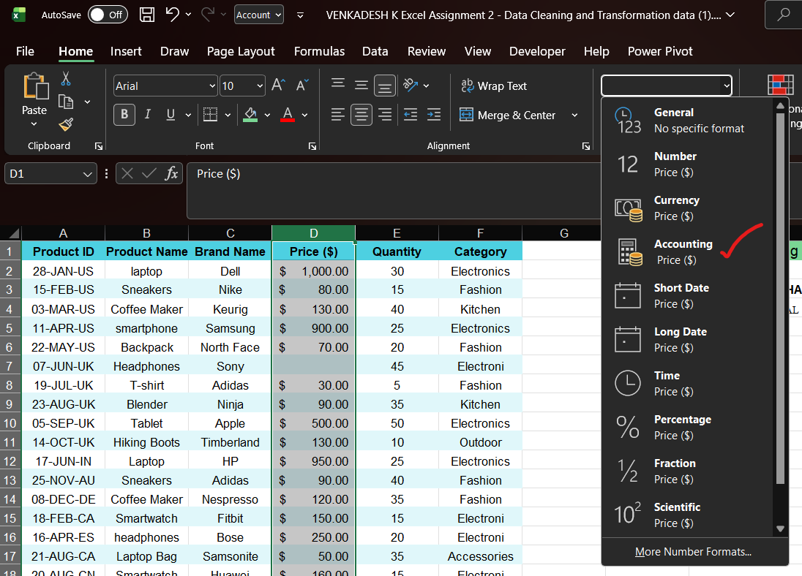

Price ($) - PRICE ($) TO USE (IF&ISBLANK&ROUND)
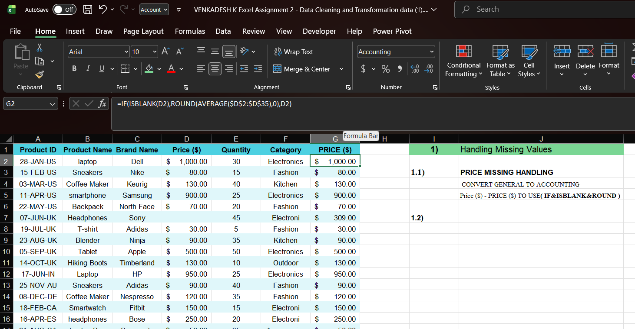

  - CATEGORY MISSING HANDLING
CONVERT GENERAL TO TEXT
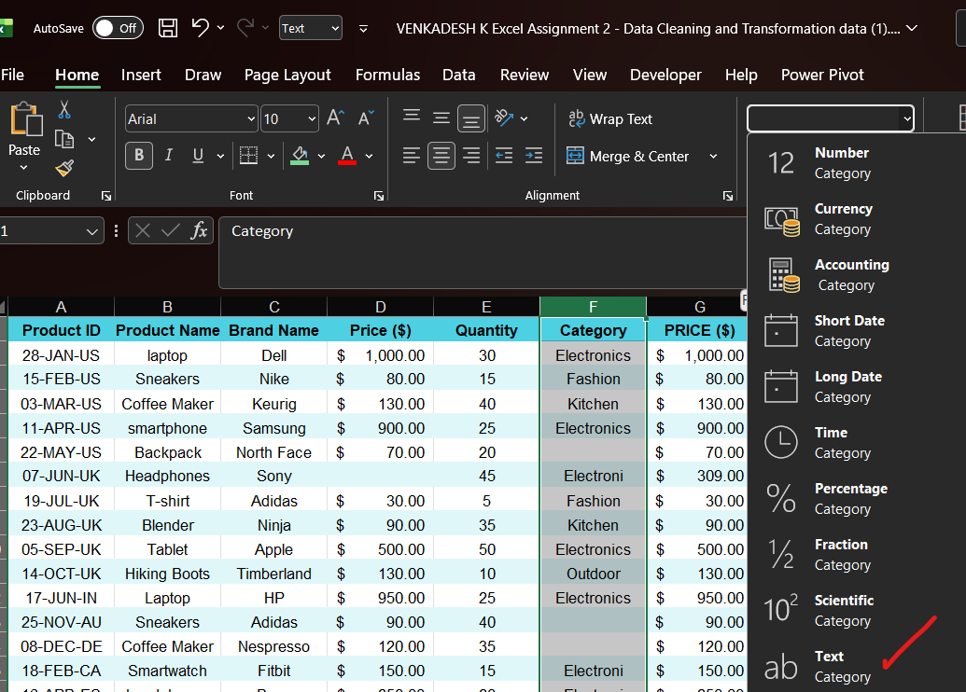
Category - CATEGORY TO USE (IF&ISBLANK) By GROUP BY
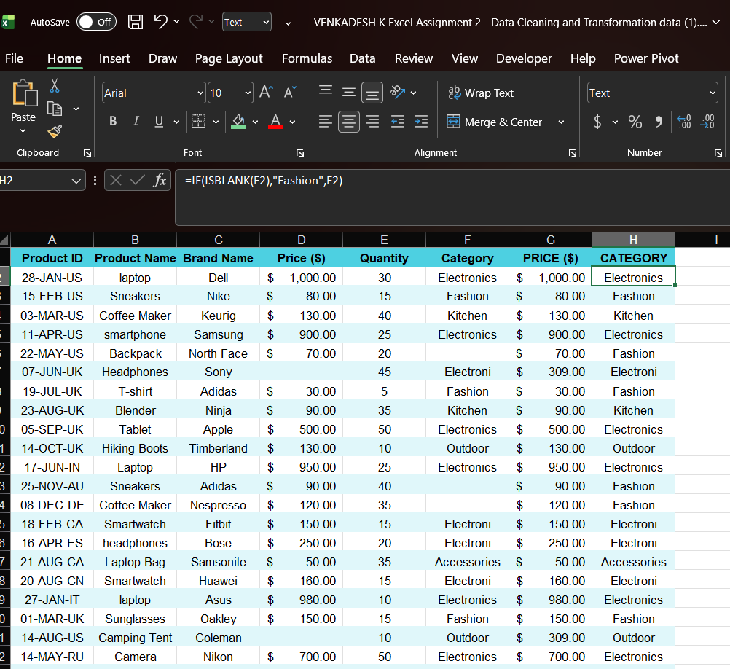

- CORRECTING INCONSISTENT DATA

2.1) IDENTIFIED INCONSISTENT TEXT FORMATS IN PRODUCT NAME
IN THIS COLUMN WE GET laptop ,smartphone ,headphones
AND CONVERT TYPOS
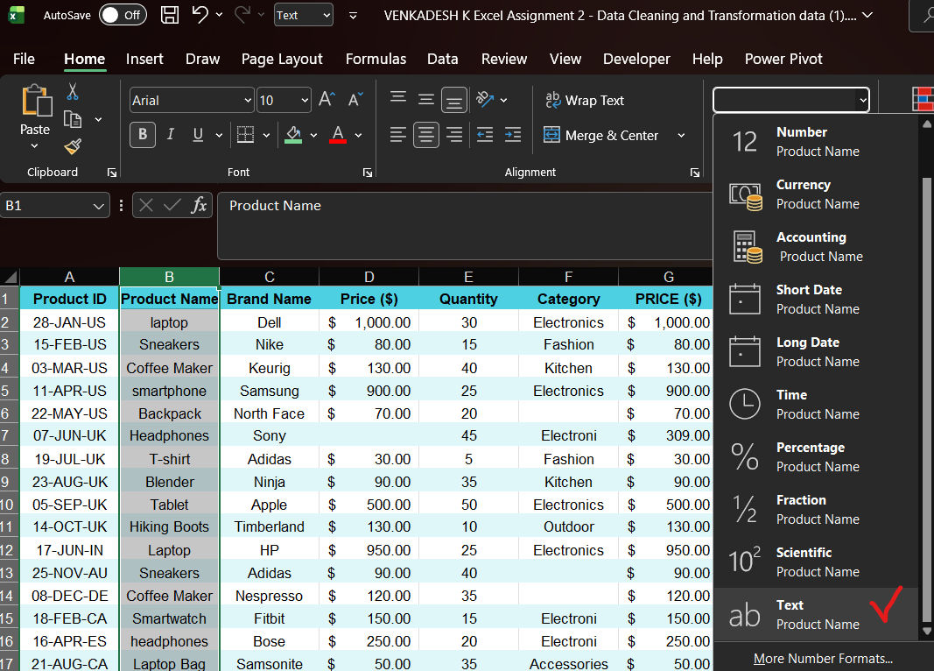
2.2) IDENTIFY ANY TYPOS PRESENT IN THE (CATEGORY)
BY IDENTIFED THE TYPOS OF CATEGORY IS (TEXT)
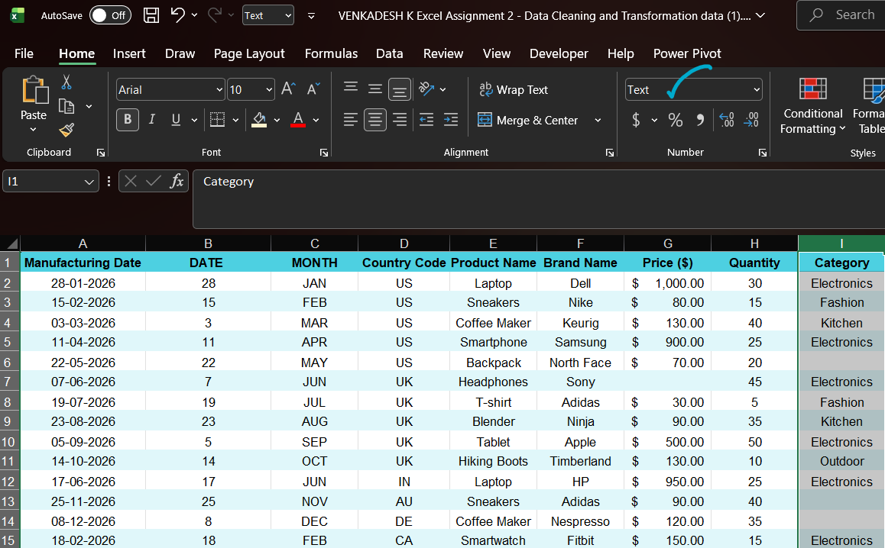
2.3) FIND AND REPLACE FUNCTION USING IN (PRODUCT NAME) AND
(CATEGORY) COLUMNS
laptop - Laptop
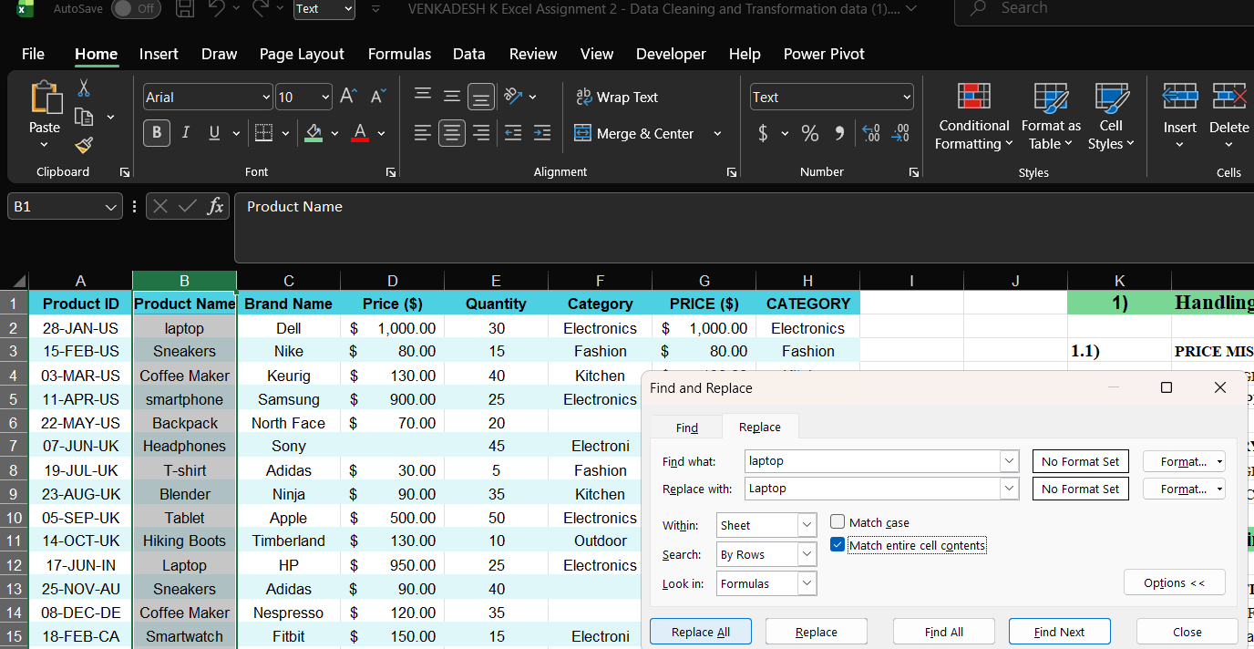

smartphone - Smartphone
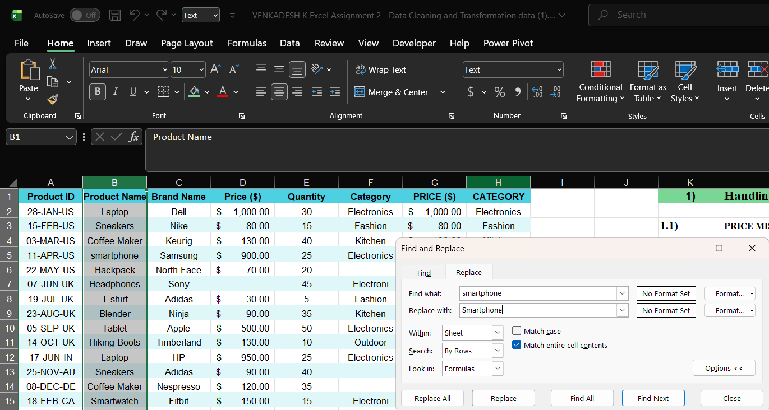
headphones – Headphones
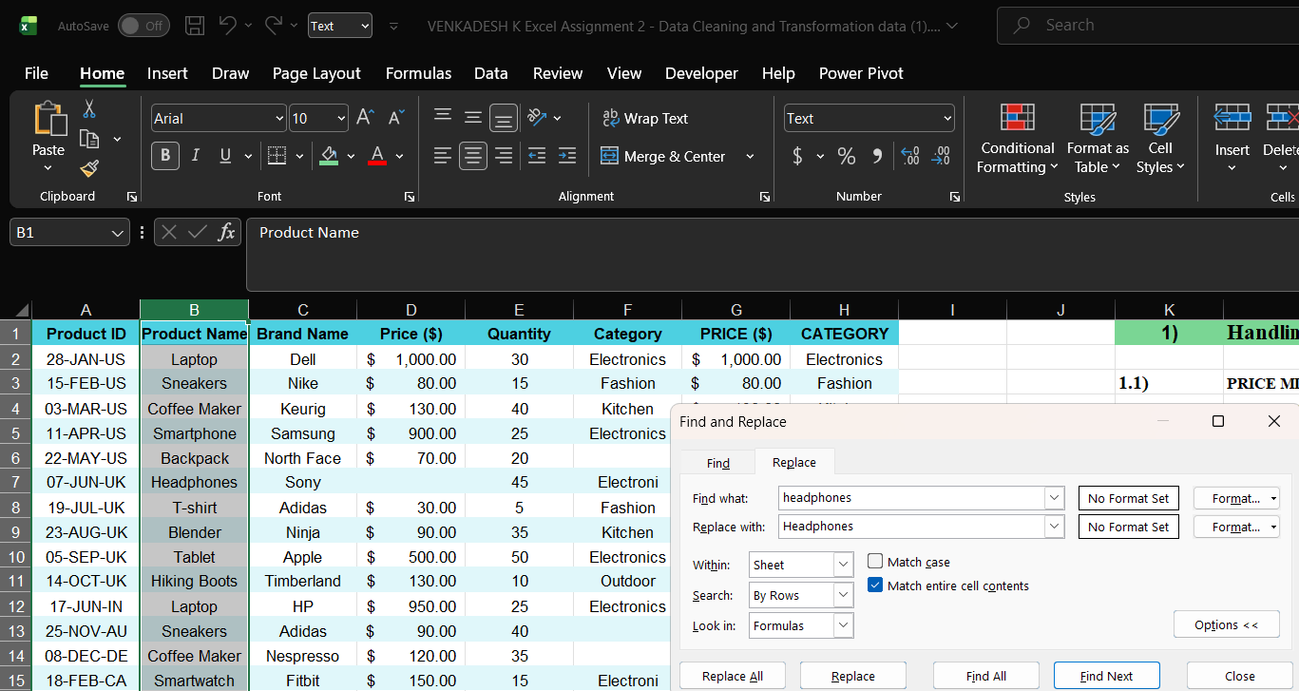
Electroni – Electronics
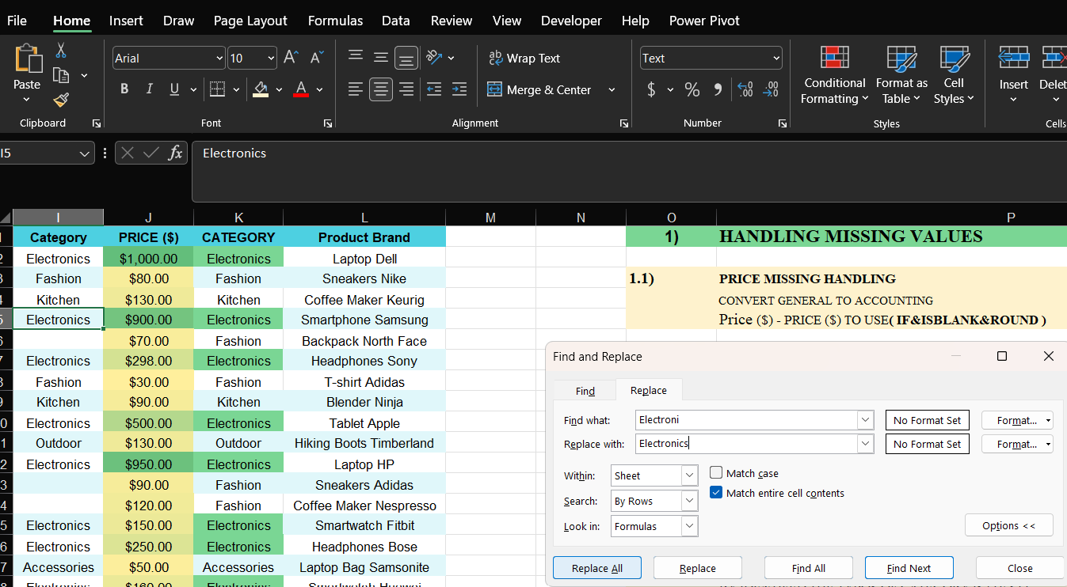

BY POWER QUERY USING GROUP-BY
MEDIAN VALUE IS “FASHION”
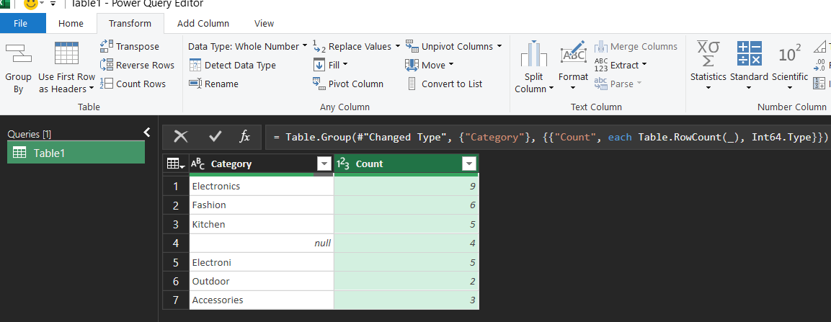
IMPUTE CATEGORY COLUMN AND FINAL VIEW OF CATEGORY

- REMOVING DUPLICATES

BY USING REMOVE DUPLICATES FEATURE
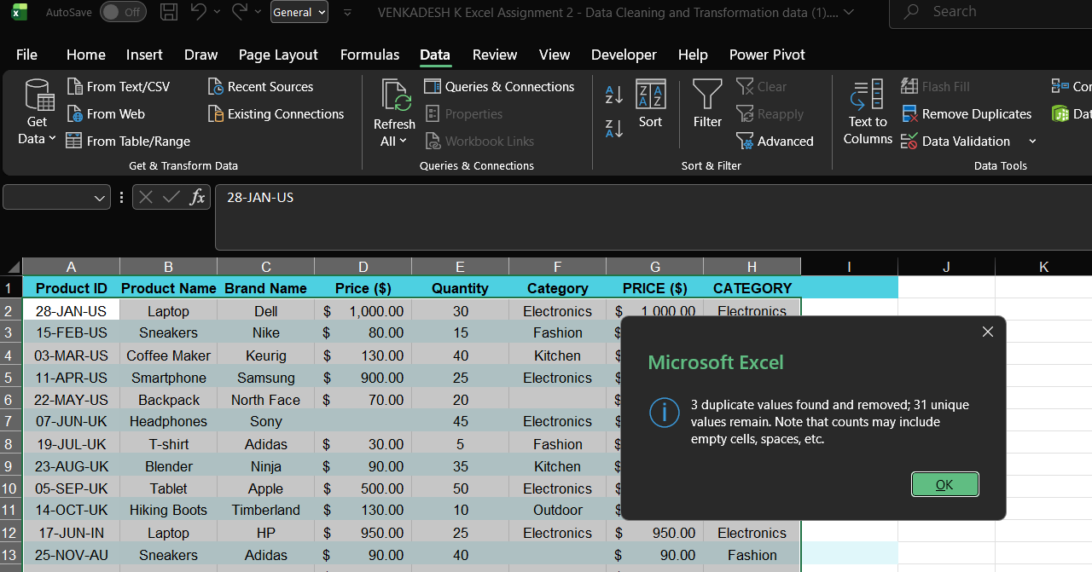

4) SPLITTING AND MERGING DATA
4.1) SPLITTING (PRODUCT ID) INTO TWO COLUMN
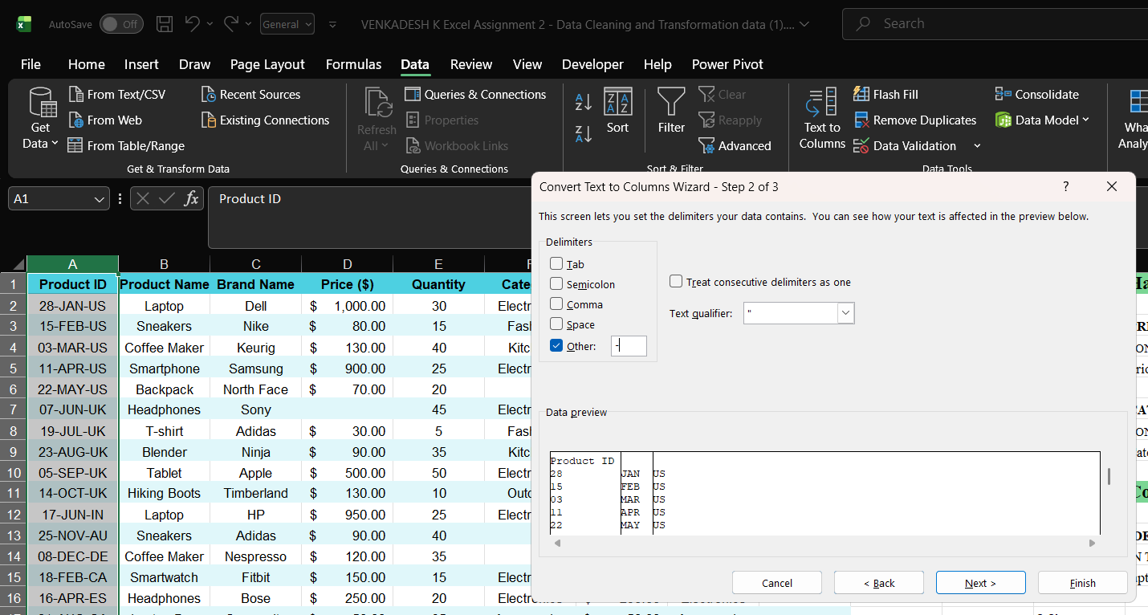

4.1.1) Manufacturing Date,Month and
Country Code 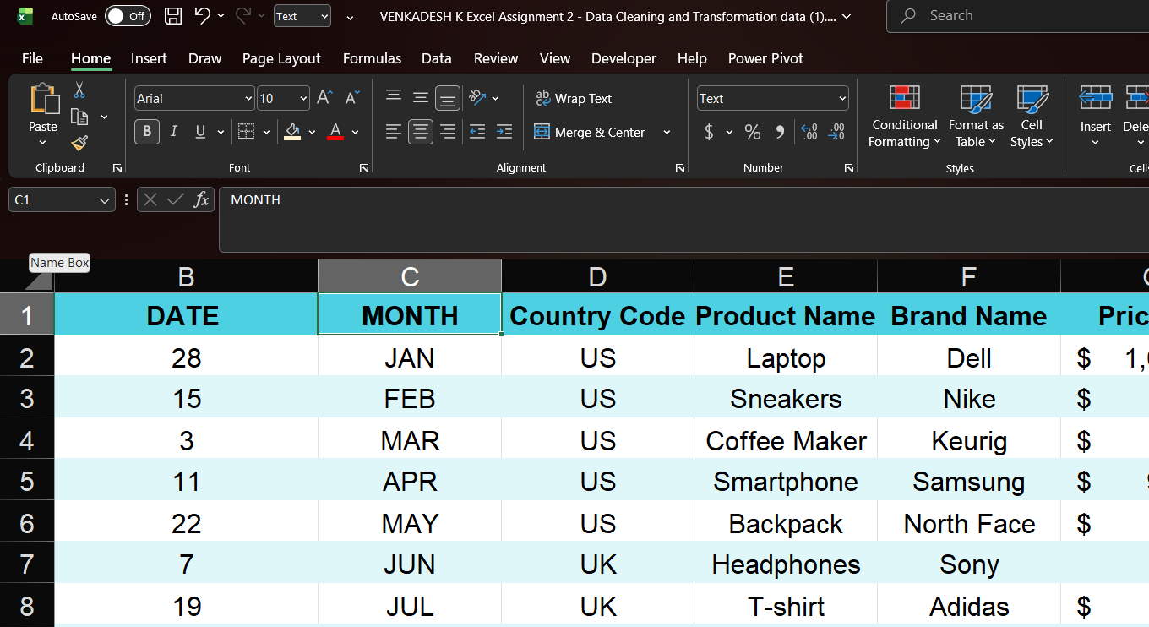

4.2) MERGEING TWO COLUMNS
Product Name & Brand = Product Brand
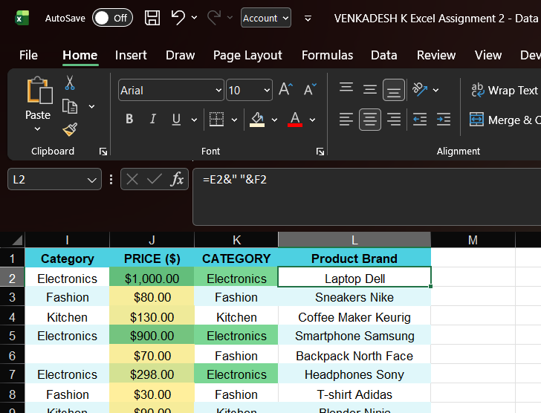

- NUMBER FORMATTING
5.1) CHANGE DATA TYPE OF (PRICE) TO CURRENCY FORMAT
ACCOUNTING TO CURRENCY FORMAT
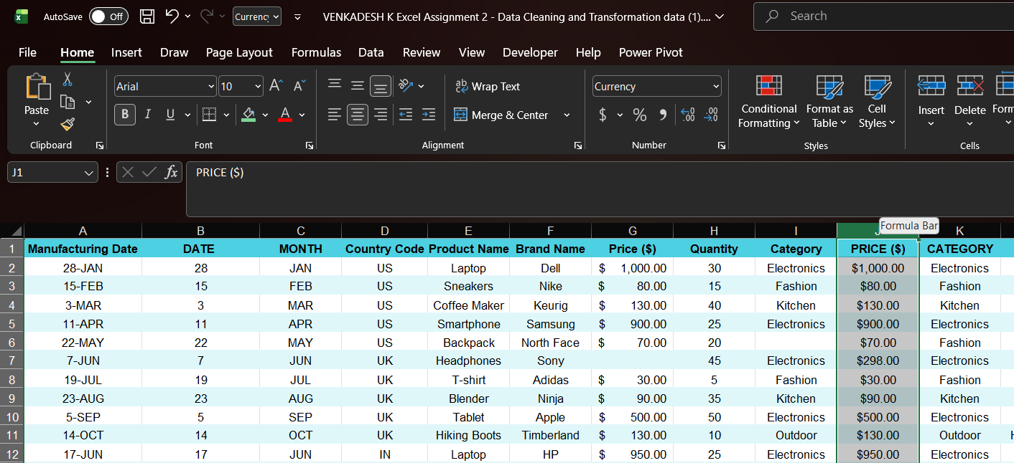
5.2) MANUFACTURING DATE DATE FORMAT
MANIFACTURING DATE FORMATE - DD-MM-YYYY
5.2.1) MANUAL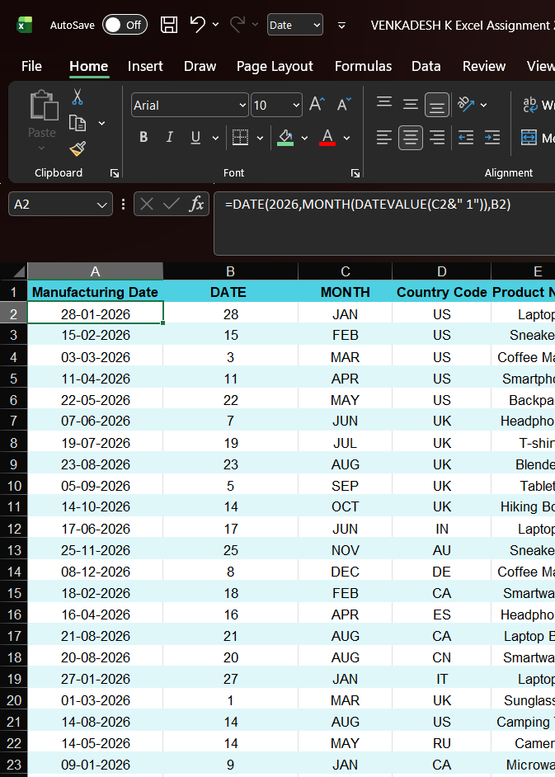
5.2.2) DATE FEATURE
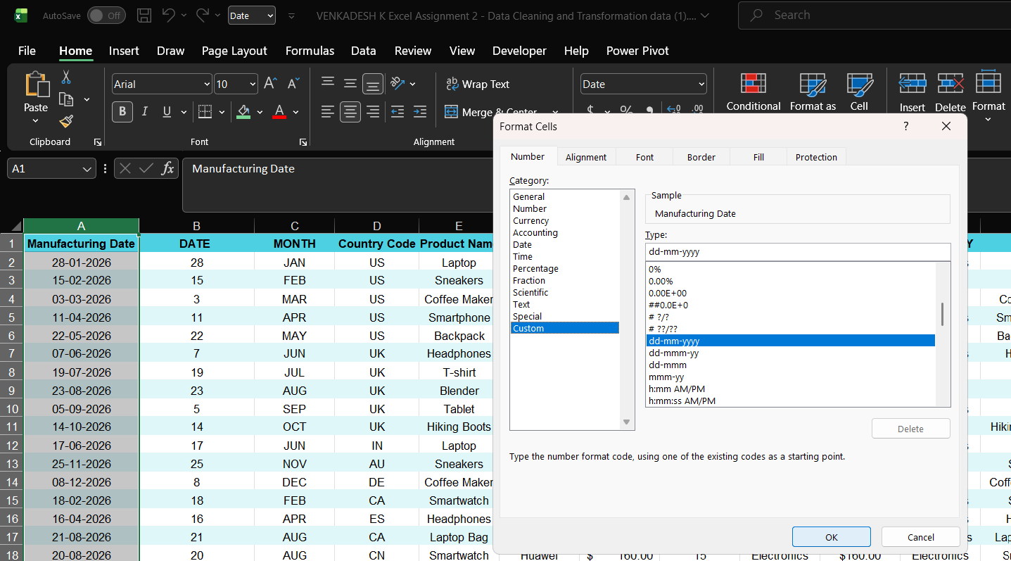

- CONDITIONAL FORMATTING
6.1) APPLYING CONDITIONAL FORMATTING IN PRICE COLUMN
APPLIED COLOR SCALE IN PRICE
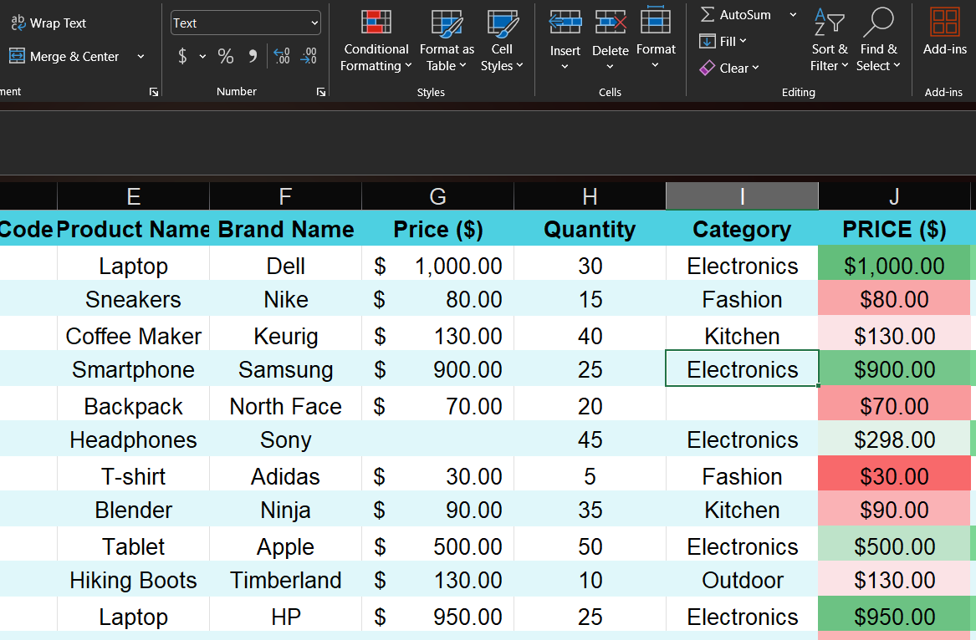

6.2) CREATING CUSTOM RULE IN CATEGORY COLUMN TO HIGHLIGHT "Electronics"
CREATED CUSTOM RULE
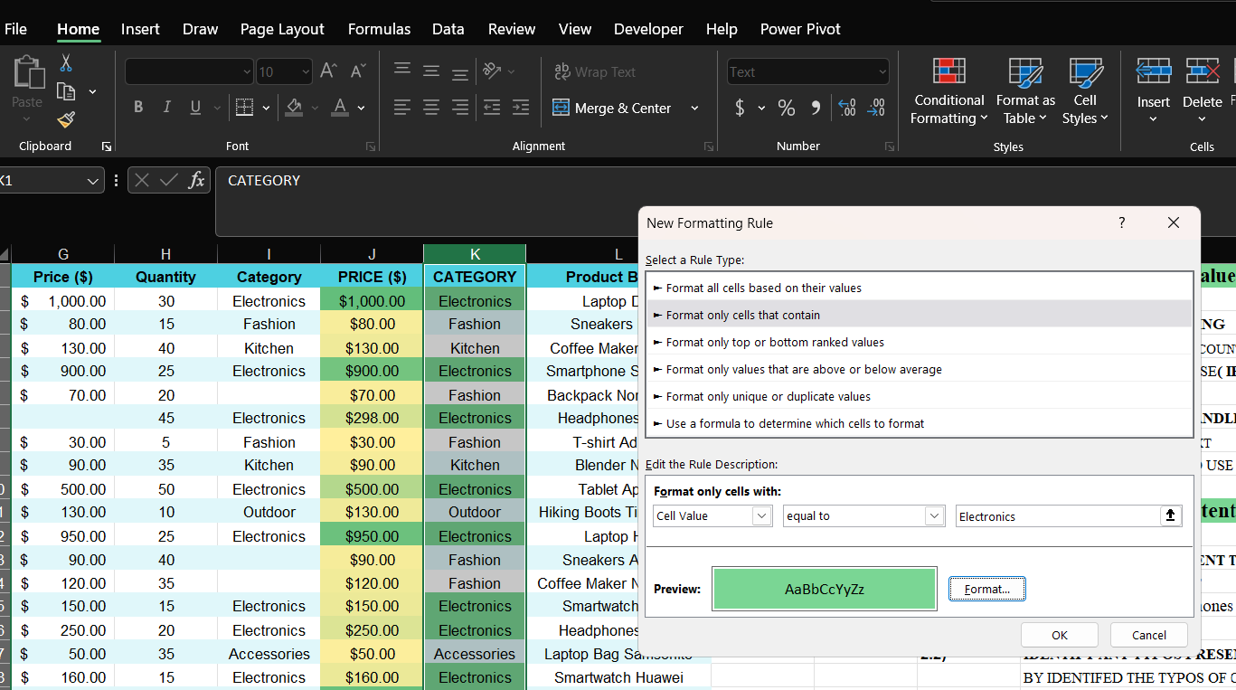

EXCEL ASSIGNMENT :
DATA CLEANING AND TRANSFORMATION:
ASSIGNMENT EXCEL LINK :
https://1drv.ms/x/c/0e84664e5b6deee1/IQB0L2cIaTixRaY4MaaZHBDKAYg2313Z0xI1CdYGgo0w3Dw?e=Lh7Fbf

OVERALL RESULT :
